For Immediate Release
Contact: Keith Severns—407-426-2300 Ext. 107
keithseverns@libertyum.com
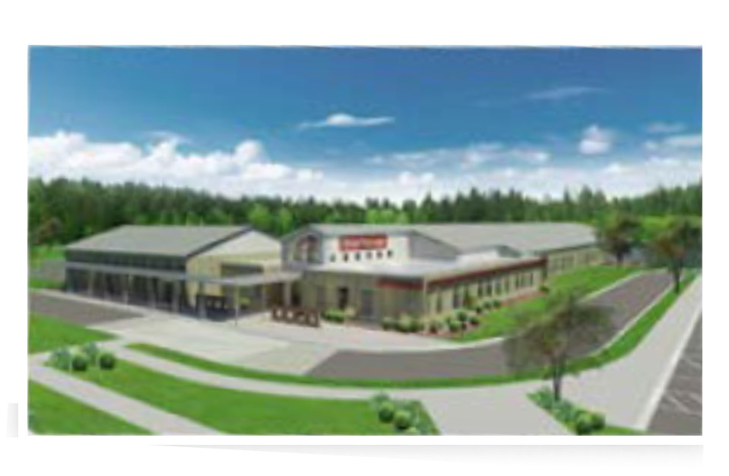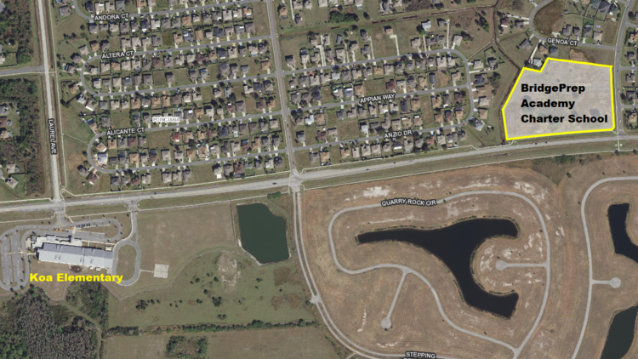

Liberty Universal Management, Inc. represents buyer in purchase of 7.45 acres for Charter School development.

Keith Severns w/Liberty Universal Management represented BridgePrep Academy Charter School in the purchase of 7.45 acres in Poinciana at the intersection of Koa Street and San Lorenzo Road. This property sold for $1.4 Million and will be the future home of BridgePrep Academy, a K-8 Charter School.

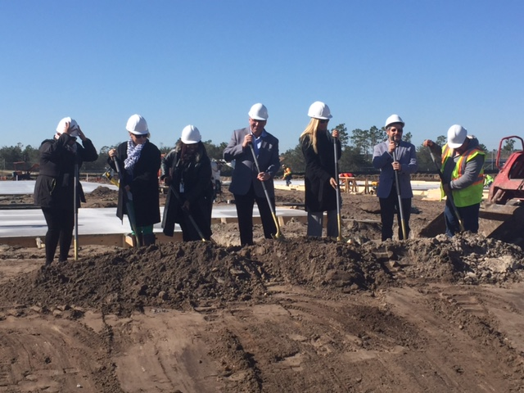
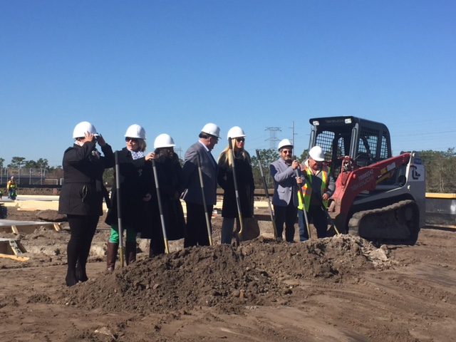
For more information on this transaction please contact Keith Severns at keithseverns@libertyum.com or 407-426-2300 ext 107.

