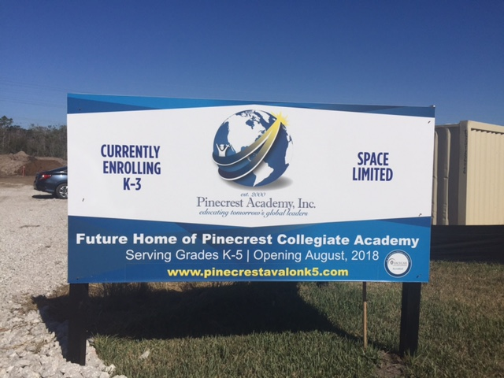

For Immediate Release
Contact: Keith Severns—407-426-2300 Ext. 107
keithseverns@libertyum.com

Liberty Universal Management, Inc. would like to Congratulate Beat Kahli for their Ground Breaking for Pincecrest Collegiate Academy, Avalon Park, Orlando, FL

Liberty Universal Management would like to Congratulate Beat Kahli, Swiss developer who created Avalon Park in East Orange County, with the groundbreaking for Pinecrest Collegiate Academy. This will be the newest charter school in Orange County. The STEM charter school is a partnership with Pinecrest Academy, Inc.

Pinecrest Collegiate Academy will be a 37,000 SF newly constructed STEM Charter school opening July of 2018 for grades K-5. Their mission: Providing Individual instruction, in a nurturing environment, ensuring college and Career success, using rigor, relevance, and relationships to empower students to become tomorrow’s global leaders.
The Vision of Pinecrest Academy, Inc. is to empower lifelong learners with knowledge and values required for productive global leadership. For more information on the School go to www.pinecrestavalonk5.com. They are currently enrolling grades Kindergarten through 3rd grade.
Liberty Universal Management will act as Construction Administration for the construction. For more information on this project please contact Keith Severns at keithseverns@libertyum.com or 407-426-2300 ext 107.

